### ****EXPERIMENT 2 : EVALUATING THE EFFECT OF CHUNKING ON USER MEMORY IN UI DESIGN****

### ****Aim:****

To design a memory game UI where users recall visual elements (icons or text chunks) after a brief exposure and evaluate the effect of chunking on memory retention.

### ****Procedure:****

1. **Understanding Chunking:**  
   Chunking is a cognitive technique where information is grouped into meaningful units to improve memory retention. In UI design, chunking helps users recognize and recall elements more efficiently by organizing them in structured patterns.
2. **Creating the Game Layout:**
   * Open **Figma** and create a **desktop frame** (e.g., 1920×1080 resolution).
   * Design a **grid-based layout** (e.g., 4×4 or 6×6), where each card represents an image or icon.
3. **Designing the Card Flip Mechanism:**
   * **Screen 1 (Exposure Phase):**
     + All cards are flipped up, revealing the images.
     + A **10-second timer** is displayed to indicate how long users can memorize the images.
   * **Screen 2 (Selection Phase):**
     + Cards are shuffled, including both **previously seen images and random distractor images**.
     + Users must recall and select the correct images they saw in **Screen 1**.
4. **Adding Interactivity in Figma:**
   * Use **prototype interactions** to automatically transition from **Screen 1 to Screen 2** after 10 seconds.
   * Add **click interactions**, allowing users to select the images they remember.
   * Provide **feedback mechanisms**:
     + Highlight correct selections in **green**.
     + Highlight incorrect selections in **red**.
5. **User Testing:**
   * Observe how well users recall images from the exposure phase.
6. **Chunked vs. Unchunked Design:**
   * Compare two UI layouts:
     + **Chunked Layout:** Images are logically grouped into categories (e.g., all animals together, all fruits together).
     + **Unchunked Layout:** Images are randomly placed without any logical grouping.

**Output:**

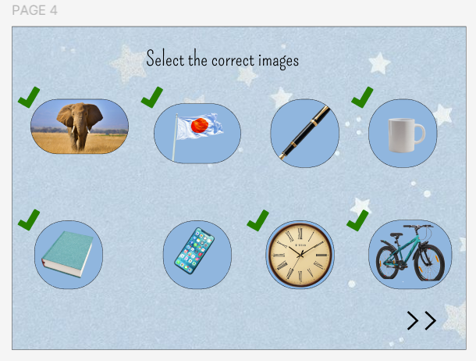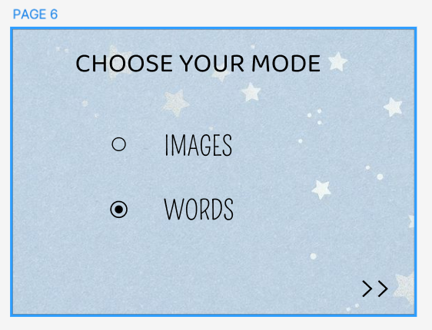

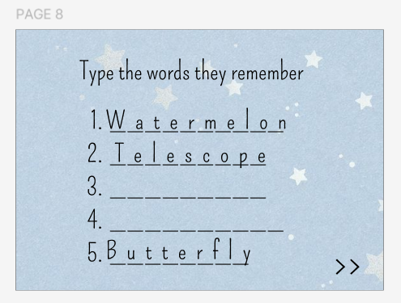

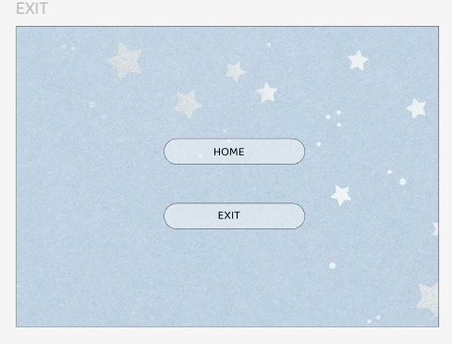

### ****Result :****

The experiment is expected to demonstrate that users perform better when images are presented in **chunked groups**, confirming that **structured information enhances memory recall**.

**Link:**

https://www.figma.com/design/nuZJ8HXygO5tsX8EaguDqf/230701334---SREYA-G---MEMORY-GAME?t=nEKZ0jUAHck25XSy-1